INDOOR FUN TO KEEP THE KIDDOS MOVING

*Freeze Dance

*Create your own dance to your favorite song

*Make an obstacle course

*Build a fort

*Play “Simon Says”

*Play charades

*Play Twister

*Ball/balloon play

*Hopscotch

*Yoga (Cosmic Kids Yoga is great!)

*Go Noodle videos (https://family.gonoodle.com)

*When you are watching television, get up and dance for the duration of each commercial

*The Dice Game - Create dice out of small boxes or other materials. Label each side with a dance step or other movement pattern. Roll the dice and perform the tasks that are facing upward!

*Animal Walks (see page 2)

Check out some of these links for more creative ideas…

https://www.todaysparent.com/family/activities/15-ways-to-keep-kids-active-indoors-even-if-you-dont-have-much-space/

https://kidsactivitiesblog.com/65765/get-kids-moving/

Resources for older children…

*Spell It Fitness (https://m.youtube.com/watch?v=hBCUmjtMVws)

*Choose It Fitness (https://m.youtube.com/watch?v=Wo9ZYTyL_tM)

ANIMAL WALKS

Elephant
Bending forward at the hips, allow the arms to hang limp. Big lumbering steps should sway you from side to side as you walk, imitating an elephant and his trunk.
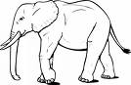

Inchworm
Support the body by hands and toes, keeping body in a straight line. With hands remaining stationary, walk the feet towards the hands, taking tiny steps. Keep the legs straight. Next, keeping the feet stationary, walk the hands forward in tiny steps until the first position is reached.
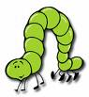

Bird
Stand on tip-toes and wave the arms slowly up and down. As the wings move faster, run tippy-toe around as if you were flying. As the flapping slows down, the bird comes slowly to a stop.
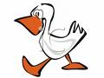

Kangaroo
Stand with the feet together. Bend the elbows and tuck hands in towards the body with hands in front. Let the hands dangle limply. Bend the knees and jump forward.
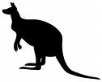

Monkey
Run forward with both hands on the floor and the knees slightly bent.
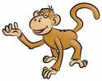

Duck
Bend your knees, place your hands around your ankles. Walk forward one foot at a time, but remain in the knee bend position.
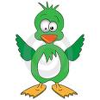

Rooster
Bending forward at the waist, grasp the ankles, keep the knees as straight as you can. Walk forward.
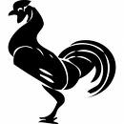

Horses Galloping
Gallop forwards with hands held simulating grasp on the reins. Change and lead off with the opposite foot.

Horses Prancing
Stand straight, with hands held simulating grasp on reins. Lift knee high with toes pointed. Just as the foot touches the ground again, lift the other knee vigorously. Repeat in a rhythmical motion with forward momentum.
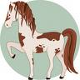

Mule Kick
Drop to a squat position. Place the palms of the hands on the floor, between the knees. Bear weight on the hands and kick the feet backwards vigorously. When the feet hit the ground, stand erect and take two steps forward. Repeat the sequence.
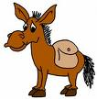

Bunny
Squat low on heels and place hands palm down on floor. Move the hands forward and bring the feet forward between the hands with a little jump.
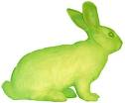

Crab
In a squatting position, reach backward with the arms and put both hands flat on the floor behind you. Raise up until the head, neck and body are in a straight line. Walk or run in this position.
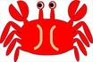

Dog
Walk on hands and feet. Weight must be forward on hands and arms.
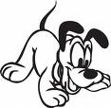

Alligator
Crawl on stomach using bent arms and legs to manoeuvre body. The right arm moves with the left leg and the left arm with the right arm.
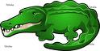

Bear
Walk on hands and feet, progress forward and backwards, moving arms and legs of the same side simultaneously. Keep the head down.
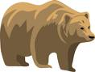

Seal
Assume a prone position on the floor. Push the body up with extended arms. Walk forward with the arms while the feet drag behind.
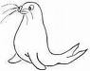

Penguin
Walk like a penguin on your heels with your arms by your side.

